IF()_FUNCTION:
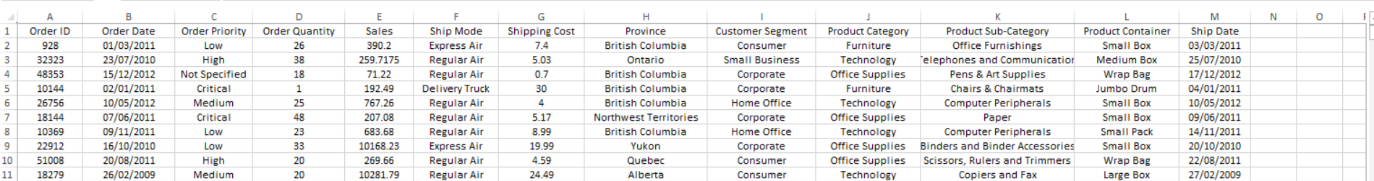

Priority: =IF([@[Order Priority]]="Critical", "Urgent", "Not Urgent")
Priority Star : =IF([@[Order Priority]]="Critical","***",IF([@[Order Priority]]="High","**","*"))
Price Classification: =IF([@Sales]>5000,"Expensive","Cheap")

